**A CRM Application to Manage the Services offered by an Institution**

By

V.Pranay Reddy

vpranayreddy03@gmail.com

**Project Abstract**

Individualized support and management of service is the most vital requirement for educational institutions that wish to capture and retain students in today's teaching scenario. This project actually aims at developing the CRM application on the Salesforce platform especially targeting educational institutions that handle the interactions with their students and services. The system will, therefore, become a centralized hub to address all activities that fall under the students' affairs-from initial inquiries and appointment scheduling to admissions guidance, immigration support, and case management throughout. In this way, workflows are automated and consolidated data is expected to decrease administrative burdens, improve student satisfaction, and make operations efficient.

This application will leverage the rich set of features that Salesforce provides to store student information in complete detail, track service requests, and streamline communication with students and consultants. Built-in analytics and reporting tools will also serve as a source of useful information for service performance. The foundation for the improvement of opportunities and resource allocation will be established. This CRM application will help promote a more responsive, organized, and supportive environment through proper management of the student and their relationships, which enables institutions to meet the needs of students in precision and care.

**INDEX PAGE**

|  |  |
| --- | --- |
| **Topics** | **Page No** |
| Cover Page | 1 |
| Project Abstract | 2 |
| Introduction | 6 |
| TASK-1 Create Objects from Spreadsheet | 7-9 |
| 1.1 Create Course object | 7 |
| 1.2 Create Remaining objects | 7 |
| 1.3 Create Relationship among the objects | 7-8 |
| 1.4 Configure the Case Object | 8 |
| 1.5 Create a Lightning App | 8-9 |
| TASK-2 Create a ScreenFlow for Student Admission Application process. | 9-13 |
| 2.1 Add Screen Element | 9 |
| 2.2 Create Student Record using Create Element | 10 |
| 2.3 Add Screen Element | 10 |
| 2.4 Add Decision Element | 10 |
| 2.5 Add GET Record Element | 10-11 |
| 2.6 Create Registration Record using Create Records Element | 11 |
| 2.7 Create Email Text Template Variables for email body and subject | 11-12 |
| 2.8 Add an Action Element | 12 |
| 2.9 Add Screen Element | 12-13 |
| TASK-3 Create Users | 13-14 |
| 3.1 User | 13 |
| 3.2 Configure the User Settings | 13-14 |
| TASK-4 Create an Approval Process for Property Object | 14-15 |
| 4.1 Create an Email Template | 14-15 |
| 4.2 Create an Approval Process | 15 |
| TASK-5 Create a Record Triggered Flow | 15-16 |
| 5.1 Configure the Start Element | 15-16 |
| 5.2 Add an Action Element | 16 |
| TASK-6 Create a ScreenFlow for Existing Student to Book an Appointment | 16-19 |
| 6.1 Add Screen Element | 16 |
| 6.2 Add GET Record Element | 16-17 |
| 6.3 Add Decision Element | 17 |
| 6.4 Add Screen Element | 17 |
| 6.5 Add GET Record Element | 17 |
| 6.6 Create Appointment Record using Create Records Element | 17-18 |
| 6.7 Add Screen Element | 19 |
| 6.8 Add an SubFlow Element | 19-20 |
| TASK-7 Create a ScreenFlow to Combine all the flows at one place | 21-22 |
| 7.1 Add Screen Element | 21 |
| 7.2 Add Screen Element | 21-22 |
| 7.3 Add Decision Element | 22 |
| 7.4 Add an SubFlow Element | 22 |
| 7.5 Add an SubFlow Element | 22-23 |
| TASK-8 Create a lightning app page | 23-24 |
| 8.1 Create a lightning app page | 23-24 |

**Introduction**

Educational institutions today offer a wide range of programs, catering to diverse student needs and ambitions. As institutions expand their offerings and attract larger student populations, managing student services effectively becomes increasingly complex. The admission process, student inquiries, appointment scheduling, and post-admission support all require streamlined management to maintain high levels of service and ensure student satisfaction. To address these challenges, this project proposes a Customer Relationship Management (CRM) application built on the Salesforce platform, designed specifically to improve the management of student services in an educational setting.

The project focuses on creating a seamless experience for students, from the first inquiry to post-enrollment support, by consolidating information and automating processes within a single CRM platform. The Salesforce-based CRM application will allow admissions and support staff to easily manage student records, track service requests, and oversee case management, all while ensuring that communication with students remains clear and consistent. By leveraging this CRM, institutions aim to enhance the efficiency of student service processes, reduce administrative workloads, and provide students with a more responsive, supportive experience.

In addition to improving process efficiency, this CRM application will offer valuable insights into service quality and student needs through built-in analytics and reporting features. These insights will help educational institutions better understand student expectations and identify opportunities for improvement in service offerings. With data-driven decision-making capabilities, staff can proactively address student needs, optimize resources, and refine service strategies to better align with institutional goals.

Ultimately, the CRM application will foster stronger relationships between institutions and their students, empowering educational providers to deliver a more personalized, effective, and professional level of support. By implementing a unified platform that integrates student information, tracks interactions, and automates workflows, the CRM system will help institutions to better meet the needs of prospective and current students, positioning them for long-term success in a competitive educational landscape.

**TASK-1 Create Objects from Spreadsheet**

1. Directly Creating Objects from Spreadsheet in Salesforce
2. Download all the spreadsheers which are provided.

**1.1 Create Course object**

1. Go to your object manager and and click on create object from spreadsheet
2. Click on the link to get the spreadsheet,Course.
3. After downloading, upload the file, map the fields and upload to create an object.

**1.2 Create Remaining objects**

1. Follow the steps which we have followed for course object creation.
2. Use the following sheets for remaining objects.
3. [Consultant](https://docs.google.com/spreadsheets/d/12q_u-63PZ3MTCgJS1voKsvTL_jVIjW4kyI_9shgB97s/edit?pli=1&gid=198933105#gid=198933105)
4. [Student](https://docs.google.com/spreadsheets/d/1QbkK_l1K5x9aBN8LXrEZfYJ0qMMLU-5NTi5O3_cCe1Q/edit?gid=1705718850#gid=1705718850)
5. [Appointment](https://docs.google.com/spreadsheets/d/1Wvk7nWFXR7xn56F8kr1WQCYs5_x6_CUZsFiZtEpVufY/edit?gid=1793530912#gid=1793530912)

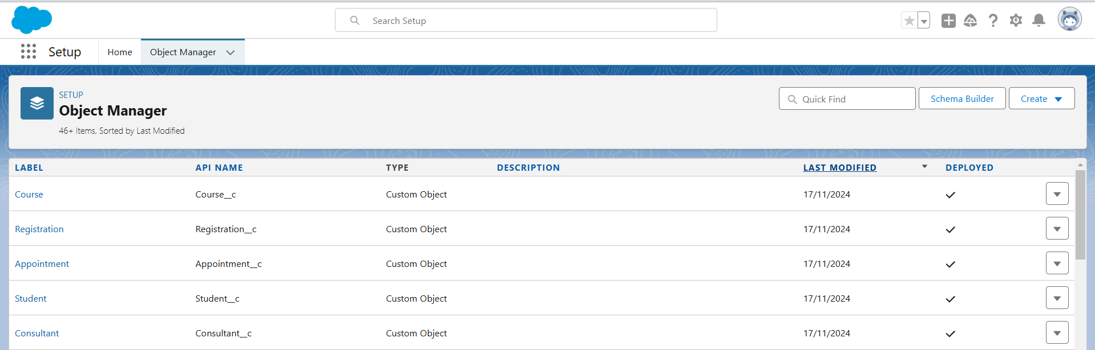

**1.3 Create Relationship among the objects**

1. Create lookup between appointment and student, appointment and consultant.
2. Create a Registration object to store student and course details.
3. Also create a lookup between student and case to store the student queries for immigration or visa application.
4. The data model should be similar to the below Data Model with fields & relationships:

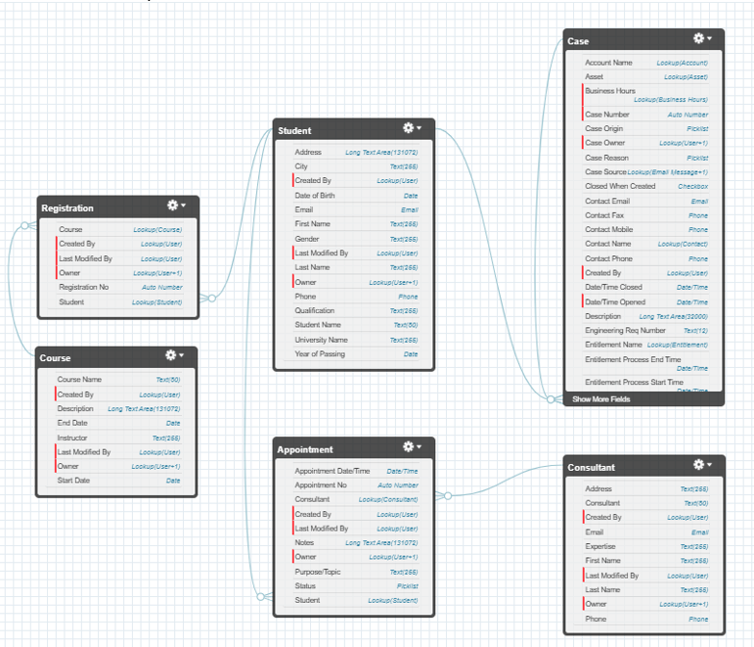

1. Create tabs for the respective object.

**1.4 Configure the Case Object**

1. Go to object manager, edit case object.
2. Select the “Type” field and add the values in it.
3. Immigration, Visa Application
4. Now Select the “Status” field and add the values in it.
5. Open, In-progress

**1.5 Create a Lightning App**

1. Go to Setup, search for the App Manager in quick find
2. Click on New Lightning App
3. Give app name as “EduConsultPro”, click Next, Next, Next
4. Add Home, Students, Courses, Consultants, Appointments, Registrations, and Cases from the Available Items to Selected Items.
5. Add “System Administrator” profile from Available Profiles to Selected Profiles, click Save & Finish.

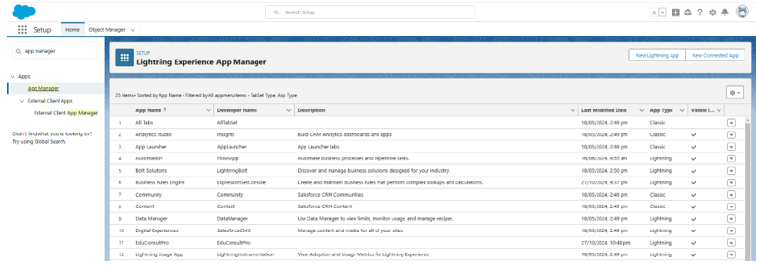

**TASK-2 Create a ScreenFlow for Student Admission Application process.**

**2.1 Add Screen Element**

1. From Setup, enter Flow Builder in quick find, select new flow --> ScreenFlow.
2. Add a Screen element.
3. In the Screen Properties pane, for Label, enter“Student Info”.
4. Click on Fields, click on the record variable input and create a new Resource(StudentRecordRes) to display all the fields which are in the student object. Drag all the fields which are needed to add on the screen inorder to collect the student information.

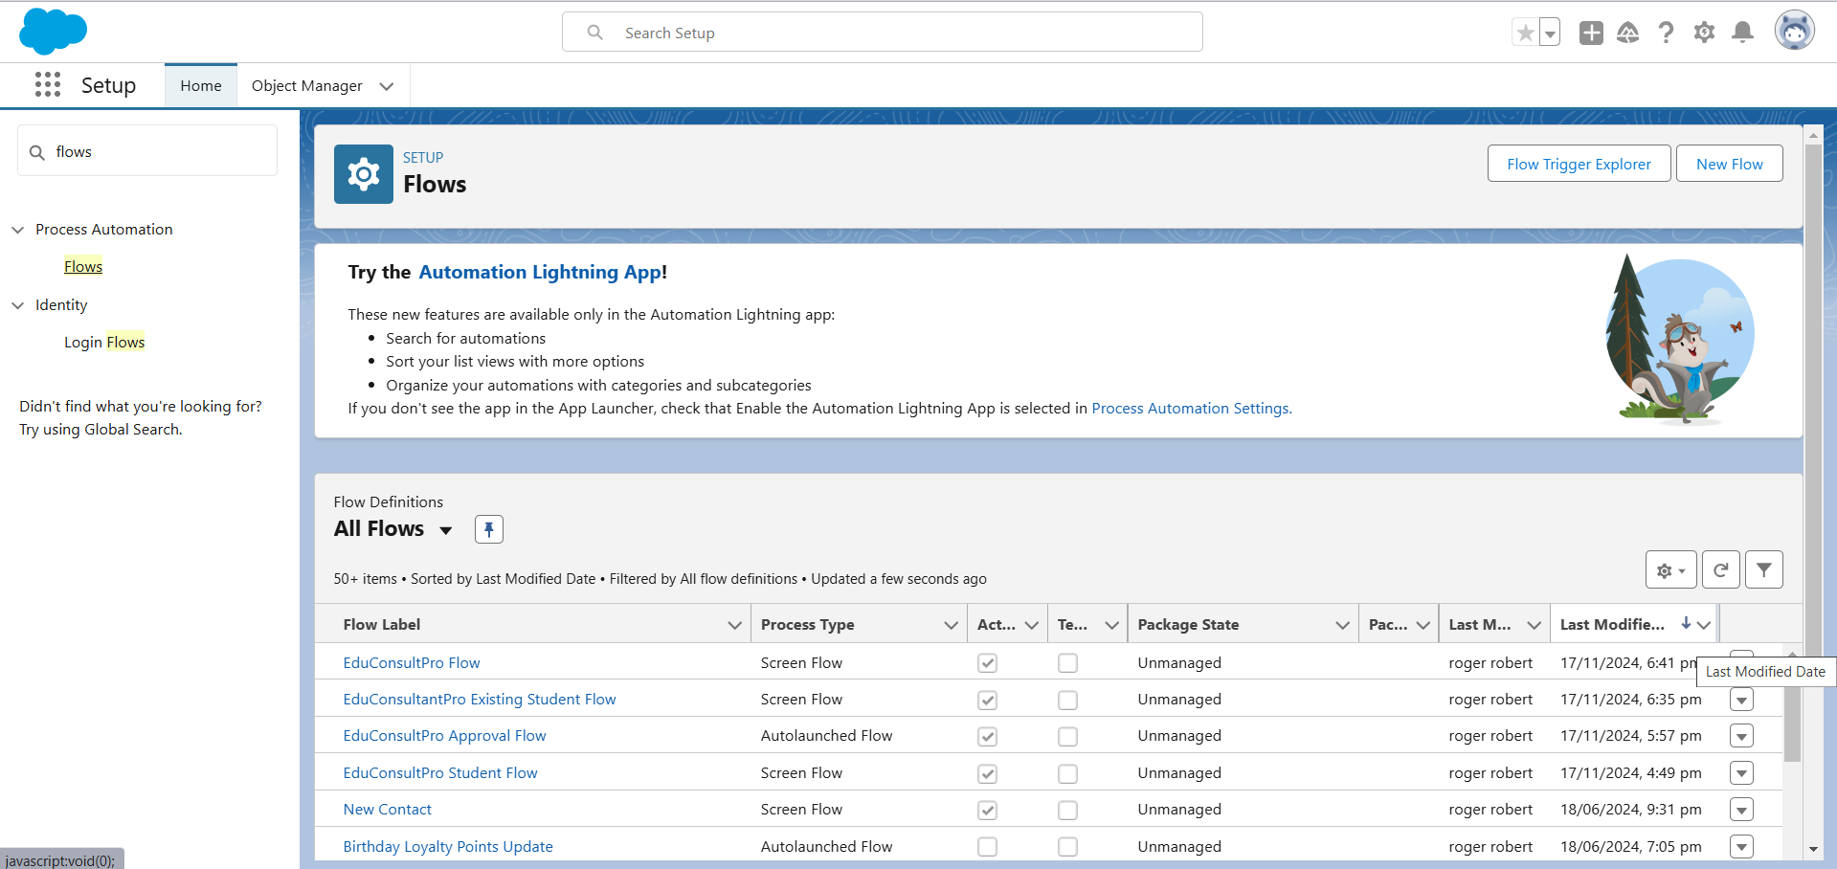

**2.2 Create Student Record using Create Element**

1. Add a Create element after Student Info Screen Element, Label it as“Create Student Record.”
2. Select “one” underHow many records to Create, and select “use all values from a record” underHow to Set the record fields.
3. Select the record variable resource(StudentRecordRes) which we have created in the Student Info screen element, underCreate a record from these values.

**2.3 Add Screen Element**

1. Add a Screen Element after Create Student Record Element and label it asCourse Screen.
2. Add a picklist component from the left side panel label it as“Select Course”, under choices type “IELTS” and enter. This creates a variable with the name IELTS.
3. Repeat the same for GRE, GMAT, Duolingo, TOEFL.

**2.4 Add Decision Element**

1. Add a Decision Element after Select Course Screen Element, label it as Selecting Course.
2. Under outcome label it as “Selected IELTS” and write the condition such as below:
3. Resource:Select_Course(Screen Component from Select Course Screen Element)
4. Operator:Equals
5. Value:IELTS(Choice Variable from Select Course Screen Element)
6. Click on the “+” icon and Repeat step 2 for other options mentioned as below:
7. GRE
8. GMAT
9. DuoLingo
10. TOEFL
11. Click Done.

**2.5 Add GET Record Element**

1. Add a GET Record Element after Decision Element, under the IELTS path and label it as “Get IELTS Rec”.
2. Select Object: Course
3. Condition Requirement: All Conditions are Met(AND)
4. a) Field: Course Name, Operator: Equals, Value: {!Select_Course}
5. Repeat the steps 1 & 2 for the GRE, GMAT, TOEFL, DuoLingo paths.

**2.6 Create Registration Record using Create Records Element**

1. Add a Create element after the Get IELTS Rec element and label it as“Create IELTS Registration Rec”.
2. Select “one” underHow many records to Create, and select “Use separate resources, and literal values” underHow to Set the record fields.
3. Select Object: Registration
4. a) Field: Course_Name__c, Value: {!Get_IELTS_Rec.Id}
5. b) Field: Student_Name__c, Value: {!StudentRecordRes.Id}
6. Repeat the steps 1 & 2 for the GRE, GMAT, TOEFL, DuoLingo paths.

**2.7 Create Email Text Template Variables for email body and subject**

1. Click on the toggle toolbox on the left corner, click “New Resource”, then select “Text Template” as Resource Type.
2. Give the API name as “StuRegistrationEmailTextTempBody”, select “view as plain text” and paste the below text in body.

“Dear {!StudentRecordRes.Name},

Congratulations and welcome to EduConsultantPro!

We are delighted to inform you that your registration on our platform has been successfully completed. You are now part of our esteemed community dedicated to empowering students like you to achieve their educational and immigration aspirations.

At EduConsultantPro, we understand the importance of your academic and career goals, and we are committed to providing you with the highest level of support and guidance throughout your journey.

Here are a few key points to help you get started:

Explore Our Resources : Take some time to explore the wide range of resources, tools, and services available on the EduConsultantPro platform. From educational insights to immigration advice, we offer comprehensive support tailored to your needs.

Connect with Our Consultants : Our team of experienced consultants is here to assist you at every stage of your educational and immigration endeavors. Don't hesitate to reach out to us with any questions, concerns, or inquiries you may have. We're here to help!

Stay Updated : Keep an eye on your inbox for important updates, announcements, and exclusive opportunities from EduConsultantPro. We'll ensure that you're informed about the latest developments and relevant information to support your journey.

Engage with the Community : Join our vibrant community of students, professionals, and experts who share your passion for education and global opportunities. Connect with like-minded individuals, participate in discussions, and expand your network.

Once again, congratulations on taking this important step towards realizing your academic and career aspirations. We are thrilled to have you as part of the EduConsultantPro family and look forward to supporting you on your journey to success.

If you have any questions or need assistance, please don't hesitate to contact us.

Thank you.”

1. Click Done.
2. Repeat steps 1 & 2 to create an email text template for the email subject, label it as “StuRegistrationEmailTextTempSub”, write a text message in the body and save it.

**2.8 Add an Action Element**

1. Add an Action Element after all the Decision paths, label it as “Send Email to Student”.
2. Under “Set input values for selected action”, include body,Recipient Address List andSubject.
3. For input Body :

{!StuRegistrationEmailTextTempBody},

Recipient Address List : {!StudentRecordRes.Email__c},

Subject : {!StuRegistrationEmailTextTempSub}.

**2.9 Add Screen Element**

1. Add a Screen Element after the Send Email to Student Action Element, label it as Success Screen.
2. From the left side panel search for the Display text component and drag it to the main panel, label it as “SuccessMessage”.
3. Paste the below in the Resource picker box.

“Dear {!StudentRecordRes.Name},

Congratulations and welcome to EduConsultantPro!

We are delighted to inform you that your registration on our platform has been successfully completed. You are now part of our esteemed community dedicated to empowering students like you to achieve their educational and immigration aspirations.

Your Registration details have been sent through mail kindly check it once.

Thank you.”

1. Click Done.
2. Save the flow and name it as “EduConsultPro Student Flow”. Your flow will look as shown below:

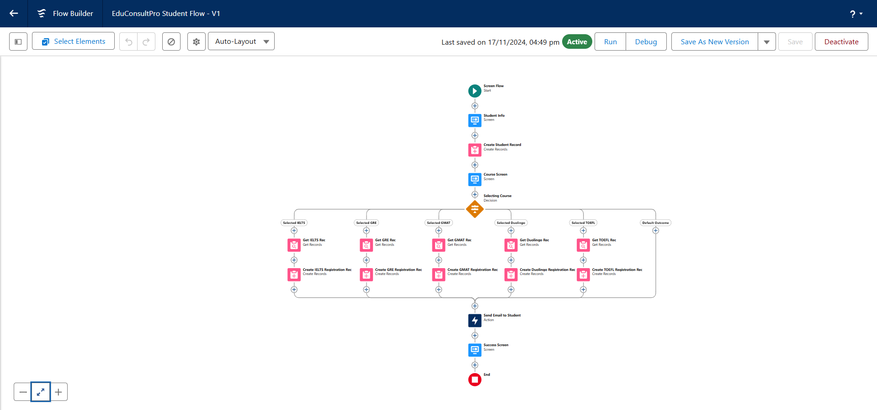

**TASK-3 Create Users**

Create a user with a Standard platform user profile.

**3.1 User**

1. Go to Setup --> Administration --> Users --> New User
2. LastName : Consultant
3. License: Salesforce Platform
4. Profile: Standard Platform User
5. Fill all the mandatory fields & Save.

**3.2 Configure the User Settings**

1. Go to Setup --> Administration --> Users --> click Edit next to your name
2. Scroll down to bottom, under Approver Settings, Select “Consultant” the Manager Field.
3. Click Save.

**TASK-4 Create an Approval Process for Property Object**

**4.1 Create an Email Template**

1. From Setup, enter Templates in the Quick Find box, and then select Lightning Email Templates, toggle on.
2. Go to app launcher, search for“Email Templates”,Create a new folder with the desired name.
3. Then create a new email template, select the folder which we have created in the previous steps, enter the below text in the HTML Value and Save it as "Submission Template".

"Dear {{{Appointment__c.Student_Name__c}}},

I hope this email finds you well. I am writing to confirm the details of our upcoming appointment scheduled for {{{Appointment__c.Appointment_DateTime__c}}} regarding {{{Appointment__c.PurposeTopic__c}}}.

Appointment Details:

Appointment No : {{{Appointment__c.Name}}},

Student Name : {{{Appointment__c.Student_Name__c}}},

Consultant Name : {{{Appointment__c.Consultant__c}}},

Date & Time : {{{Appointment__c.Appointment_DateTime__c}}},

Purpose : {{{Appointment__c.PurposeTopic__c}}}

I want to assure you that I am looking forward to our meeting and am fully prepared to address any questions or concerns you may have regarding {{{Appointment__c.PurposeTopic__c}}}. Your success and satisfaction are my top priorities, and I am committed to providing you with the guidance and support you need.

If you have any specific topics or questions you would like to discuss during our appointment, please feel free to share them with me in advance. This will help ensure that our time together is as productive and beneficial as possible.

If for any reason you need to reschedule or cancel our appointment, please notify me at your earliest convenience so that we can make alternative arrangements.

Once again, thank you for choosing to work with me on this matter. I am confident that our collaboration will lead to positive outcomes and progress toward your goals.

If you have any questions or require further information before our scheduled appointment, please don't hesitate to reach out to me.

Looking forward to our meeting.

Best regards,

{{{Recipient.Name}}},

EduConsultantPro"

1. Create two more Email templates for Approval and Rejection of Request similar to the previous one.

**4.2 Create an Approval Process**

1. From Setup, enter Approval in the Quick Find box, and then select Approval Processes.
2. In Manage Approval Processes For, select Appointment.
3. Click Create New Approval Process --> Use Jump Start Wizard.
4. Configure the approval process.
5. Process Name - Appointment Approval, Under Select Approver,Select Managerfor the option :“Automatically assign an approver using a standard or custom hierarchy field.”
6. Click next and“Next Automated Approver Determined By” --> Select Manager.
7. From Record Editability Properties --> Click on AdministratorsORthe currently assigned approver can edit records during the approval process.
8. Save the approval process.
9. Click View Approval Process Detail Page.
10. Under Initial Submission Actions, click Add New --> Field Update, and configure it with these values.

**Field** **Value**

Name Submitted

Field to Update Appointment: Status

A Specific value Pending

1. click Add New --> Email Alert, and configure it with these values.

Description : Submission Email Alert

Unique Name : Auto Populates

Email Template : Submission Template

Recipient Type : Select your Name

1. Repeat the Steps 10 - 11 for Final Approval and Final Rejection actions.

**TASK-5 Create a Record Triggered Flow**

**5.1 Configure the Start Element**

1. From Setup, enter Flows in the Quick Find box, then select Flows.
2. Click New Flow.
3. Select Record-Triggered Flow.
4. Click Create. The Configure Start window opens.
5. For Object, select Appointment.
6. For Trigger the Flow When, select A record is created.

**5.2 Add an Action Element**

1. Add an Action element after the Start Element and Select the Submit for approval action, label it as “Approval SubFlow”.
2. Set the RecordId to “{!$Record.Id}”.
3. Save the Flow, label it as "EduConsultPro Approval Flow and Click on Activate.

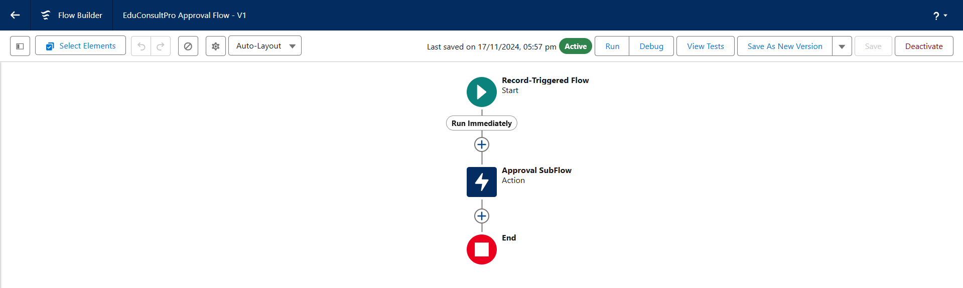

**TASK-6 Create a ScreenFlow for Existing Student to Book an Appointment**

**6.1 Add Screen Element**

1. From Setup, enter Flow Builder in quick find, select new flow ? ScreenFlow.
2. Add a Screen element.
3. In the Screen Properties pane, for Label, enter“Get Student Info”.
4. Add two Text components from the left side panel. Give the Label’s as follows:
5. 1st Text Component Label : Enter Student Name
6. 2nd Text Component Label : Enter Student Email
7. Click on Done.

**6.2 Add GET Record Element**

1. Add a GET Record Element after Decision Element, under the IELTS path and label it as “Get Rec”.
2. Select Object: Student

Condition Requirement: All Conditions are Met(AND)

Field: Student Name

Operator: Equals

Value: {!Enter_Student_Name}

Field: Email__c

Operator: Equals

Value: {!Enter_Student_Email}

**6.3 Add Decision Element**

1. Add a Decision Element after Select Display Student Details Element, label it as “Appointment or Case”.
2. Under outcome label it as “Appointment” and write the condition such as below:
3. Resource : {!How_may_I_Help_you}
4. Operator : Equals
5. Value : {!Book_an_Appointment}
6. Click on the “+” icon and Repeat step 2 for Case options mentioned.

**6.4 Add Screen Element**

1. Add a Screen element after the Decision Element, on the Appointment path and label it as “Appointment Booking Screen".
2. Click on Fields, click on the record variable input and create a new Resource (AppointmentRecordRes) to display all the fields which are in the Appointment object.
3. Drag all the fields which are needed to add on the screen inorder to collect the student information.
4. Click on Done.

**6.5 Add GET Record Element**

1. Add a GET Record Element after Decision Element, under the Appointment path and label it as “Get Consultant Rec”.
2. Select Object : Consultant
3. Condition Requirement : All Conditions are Met(AND)
4. Field : Name
5. Operator : Equals
6. Value : {!AppointmentRecordRes.Consultant_Name__c}

**6.6 Create Appointment Record using Create Records Element**

1. Add a Create element after the Get Consultant Rec element and label it as “Create Appointment”.
2. Select “one” under How many records to Create, and select “Use separate resources, and literal values” under How to Set the record fields.
3. Select Object : Appointment
4. Field : Appointment_DateTime__c
5. Value : {!AppointmentRecordRes.Appointment_DateTime__c}
6. Field : Consultant__c
7. Value : {!Get_Consultant_Rec.Id}
8. Field : Notes__c
9. Value : {!AppointmentRecordRes.Notes__c}
10. Field : PurposeTopic__c
11. Value : {!AppointmentRecordRes.PurposeTopic__c}
12. Field : Student_Name__c
13. Value : {!Get_Rec.Id}

**6.7 Add Screen Element**

1. Add a Screen Element after the Send Email to Student Action Element, label it as “Confirmation Screen”.
2. From the left side panel search for the Display text component and drag it to the main panel, label it as “Appointment_Confirmation”.
3. Paste the below in the Resource picker box:

Consultant Name : {!Get_Consultant_Rec.Name},

Date & Time : {!AppointmentRecordRes.Appointment_DateTime__c},

Notes : {!AppointmentRecordRes.Notes__c},

Ststus : {!AppointmentRecordRes.Status__c}

1. Click Done.

**6.8 Add an SubFlow Element**

1. Add a subflow element after the Decision Element, on the Case path and search and Select for “Create a Case”, label it as “Create Student Case”.
2. Save the flow and label it as “EduConsultantPro Existing Student Flow”, you can use the below image for reference.

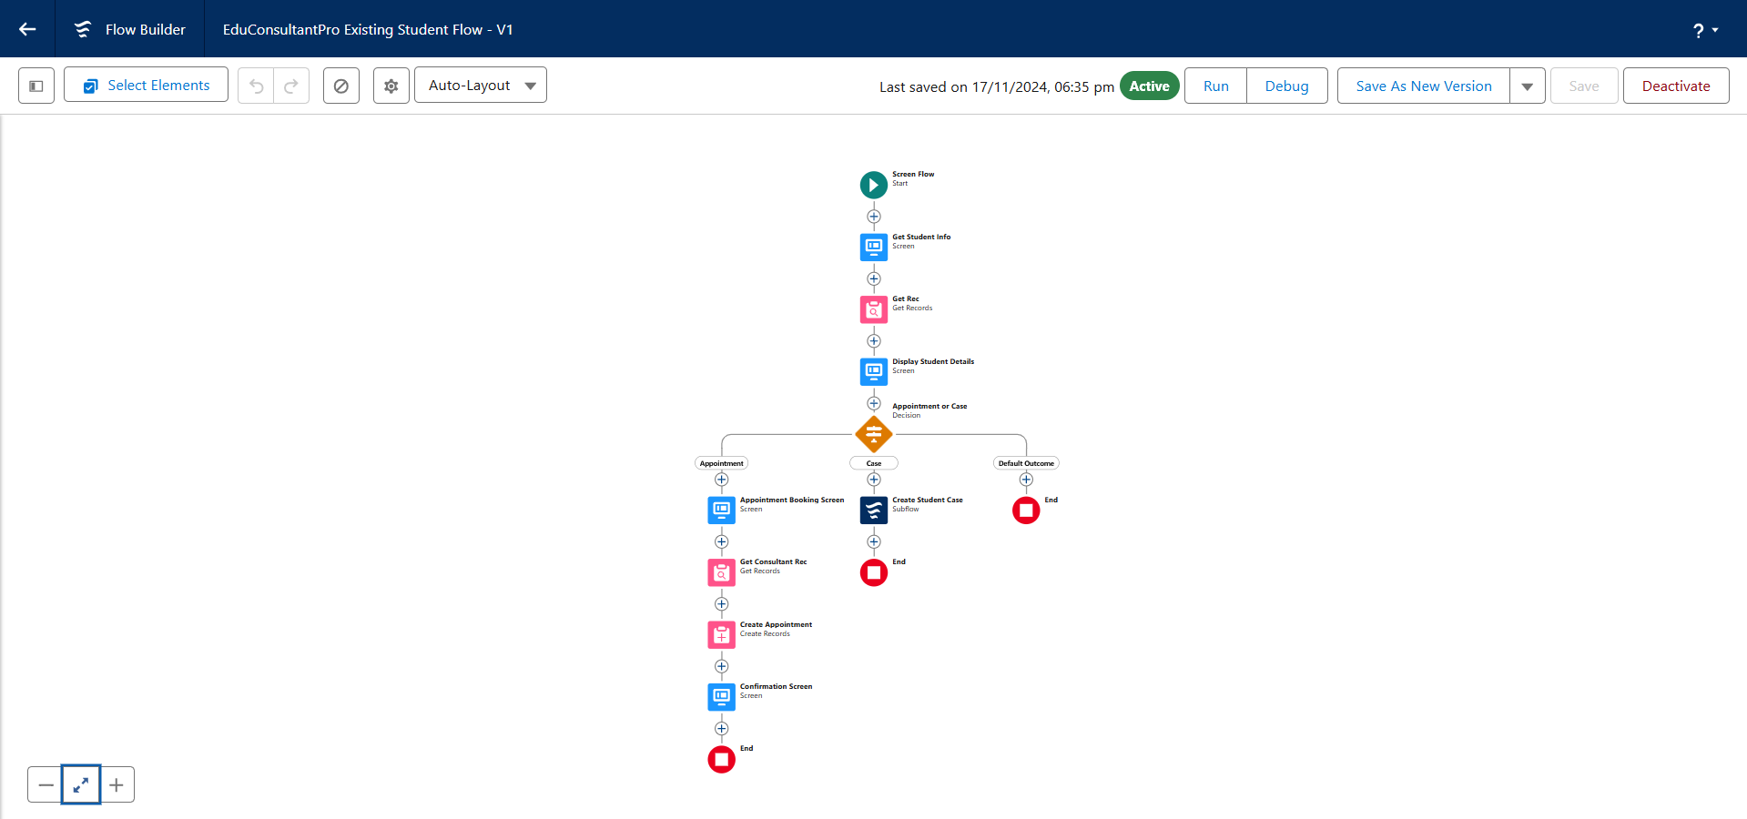

**TASK-7 Create a ScreenFlow to Combine all the flows at one place**

**7.1 Add Screen Element**

1. Add a Screen Element and label it as Welcome Screen.
2. From the left side panel search for the Display text component and drag it to the main panel, label it as “SuccessMessage”.
3. Paste the below in the Resource picker box.

“Welcome to EduConsultantPro

your premier destination for education and immigration solutions!

At EduConsultantPro, we understand that embarking on educational or immigration journeys can be both exhilarating and daunting. That's why we're here to guide you every step of the way with expertise, dedication, and personalized support.

Whether you're seeking to pursue your academic dreams abroad, navigate the complexities of immigration processes, or enhance your professional skills through international opportunities, EduConsultantPro is your trusted partner.

Our team of seasoned consultants is committed to understanding your unique aspirations and crafting tailored strategies to help you achieve your goals efficiently and effectively. From selecting the right educational institution to navigating visa procedures, our comprehensive services cover all aspects of your journey.

At EduConsultantPro, we believe in fostering inclusive communities and unlocking the full potential of every individual. With our unwavering commitment to excellence and integrity, we strive to make your experience with us seamless and rewarding.

Welcome to EduConsultantPro – where your aspirations meet our expertise, and together, we pave the path to success. Let's embark on this transformative journey together!”

1. Click Done.

**7.2 Add Screen Element**

1. Add a Screen Element after the Welcome Screen Element, label it as “Existing or New Student Confirmation Screen”.
2. Add a radio button component from the left side panel,
3. label : Are you a Existing Student
4. Click on Add Choice --> type “Yes” in the input field --> click Create Yes choice.
5. Repeat step 6 and create an “No” choice resource.
6. Click Done.

**7.3 Add Decision Element**

1. Add a Decision Element after Existing or New Student Confirmation Screen Element, label it as “Decision 1”.
2. Under outcome label it as “If Existing Student” and write the condition such as below:
3. Resource:{!Are_you_a_Existing_Student}
4. Operator:Equals
5. Value:{!Yes}
6. Click on the “+” icon and Repeat step 2 for No options mentioned.

**7.4 Add an SubFlow Element**

1. Add a subflow element after the Decision 1 Element on the if Existing Student path and search and Select for “EduConsultantPro Existing Student Flow '', label it as “Existing Student Flow”.
2. Save the flow and label it as “EduConsultantPro Existing Student Flow”.
3. Click Done.

**7.5 Add an SubFlow Element**

1. Add a subflow element after the Decision 1 Element on the if Not an Existing Student path and search and Select for “EduConsultantPro Student Flow '', label it as “New Student Flow”.
2. Save the flow and label it as “EduConsultantPro Existing Student Flow”.
3. Click Done.
4. Save the flow and label it as “EduConsultPro Flow”, you can use the below image for reference.

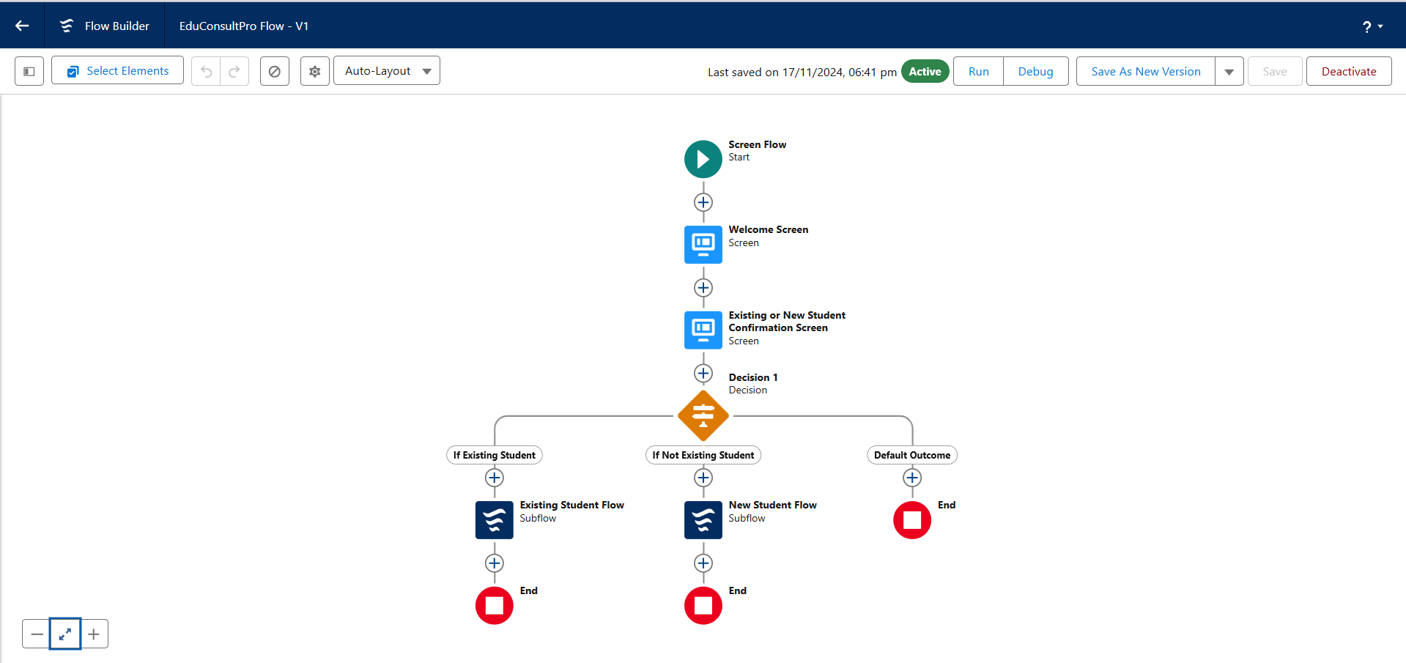

**TASK-8 Create a lightning app page**

Create a lightning app page and make it available at the application

**8.1 Create a lightning app page**

1. From Setup, enter App Builder in the Quick Find box, then click Lightning App Builder.
2. Click New, select Home Page, then click Next.
3. Step through the wizard and name the page “EduConsultPro Home Page”, select the Standard Home Page template, and then click Done.
4. Drag the Flow component to the top-right region.
5. Search for the “EduConsultantPro Flow” and click Save.
6. Click Activate, Click App and Profile, then click Assign to Apps and Profiles.
7. Select the Sales app, then click Next.
8. Scroll down the list of profiles and select System Administrator, then click Next.
9. Review the assignment, and then click Save.

